Our Lady of Furness Parish
Invite you to a
CONCERT
by
The Resurrection Choir of Saint Petersburg
who will perform a programme of
Russian Sacred Music & Folk Music
Conductor & Musical Director – Jurij Maruk

St Mary’s Church, Duke Street, Barrow
Tuesday, 3rd November 2015 at 7:30pm

This is the second visit of the Voskresenije (Resurrection) Choir, a 9-strong, mixed voice, professional choir from St Petersburg, who studied music at the St Petersburg Conservatory.  They are currently touring the UK and have performed in many countries across Europe.  You can preview their singing at http://voskresenije.blogspot.co.uk/ | 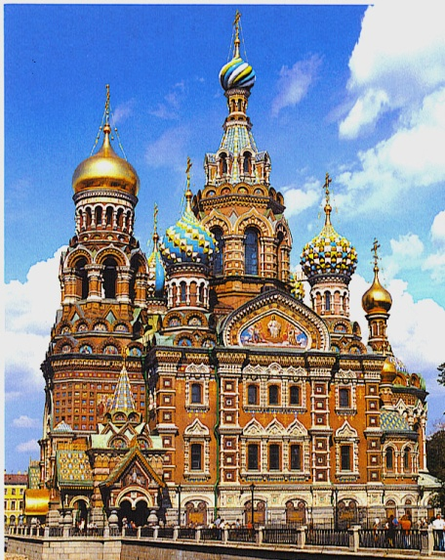
Tickets are available from all four of the Parish churches after Mass
or from the Parish Office at St Mary’s Presbytery (10am – 2pm, Mon – Fri)
Tickets: £8 in advance or £10 at the door.
Refreshments will be available during the Interval

