Our Lady of Furness Parish

Concert
of
Russian Sacred Music
and Folk Music
by
The Resurrection Choir of Saint Petersburg

St. Mary’s Church, Duke St., Barrow

Tuesday, 3rd November 2015
7:30pm

Part One - Sacred Music
In that we have beheld the  Resurrection of Christ | S.Rachmaninov  (1873-1943)
Hail, O Virgin, birth-giver of God | S.Rachmaninov
Lord, now letters Thou | S.Rachmaninov
We sing to you | S.Rachmaninov
Do not cast me off in the time of  old age | P.Tshesnokov  (1877-1944)
Let my prayer arise | P.Tshesnokov
Blessed is the man | P.Tshesnokov
Agnus Dei | Camille Saint-Saens  (1835-1921)

Interval - 20 Minutes

Refreshments are available during the Interval.
Also available – CDs and Russian Artifacts

Part Two- Folk Songs

In a sunny clearing

Carol of the Bells (Ukrainian folk song)

Black-eyed Cossack

Coachman, don’t whip up the horses

Old Bursh Song (Down deep within the cellar)

Those were the days

The lonely little bell

The members of the Resurrection Choir are:

Jurij Maruk Conductor

Anatoly Artamonov Basso Profundo

Evgeniia Borisova Alto

Vitalii Nagibin Counter Tenor

Ganna Zhivaeva Soprano

Marina Trufanova Alto

Dmitrii Petrov Tenor

Mariia Rozhkova Soprano

Jurij Zariadnov Bass

The Resurrection Choir
of Saint Petersburg

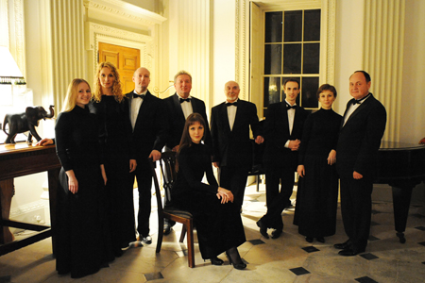
This is the second visit of the Voskresenije (Resurrection) Choir to Barrow. The audience at last year’s concert were astounded by the quality of their singing and the range of music they covered in the two halves of the programme. We hope you are equally impressed by this year’s performance.
Jurij Maruk founded the "Voskresenije" ensemble in 1993. It consists of a group of eight professional singers who studied music at the St Petersburg Conservatory, including one of only two basso profundo singers in St. Petersburg capable of reaching the lowest notes required in Rachmaninov's "Vespers".
They are currently undertaking an extensive, 2-month long tour of the UK and have performed in many countries across Europe.
Be prepared to be surprised, to hear some amazing sounds and to experience literally awesome music, the like of which, you are unlikely to hear again until you come to listen to the Resurrection Choir when they return to entertain us again.
To find out more about the Choir you can visit their website at: http://voskresenije.blogspot.com/

